

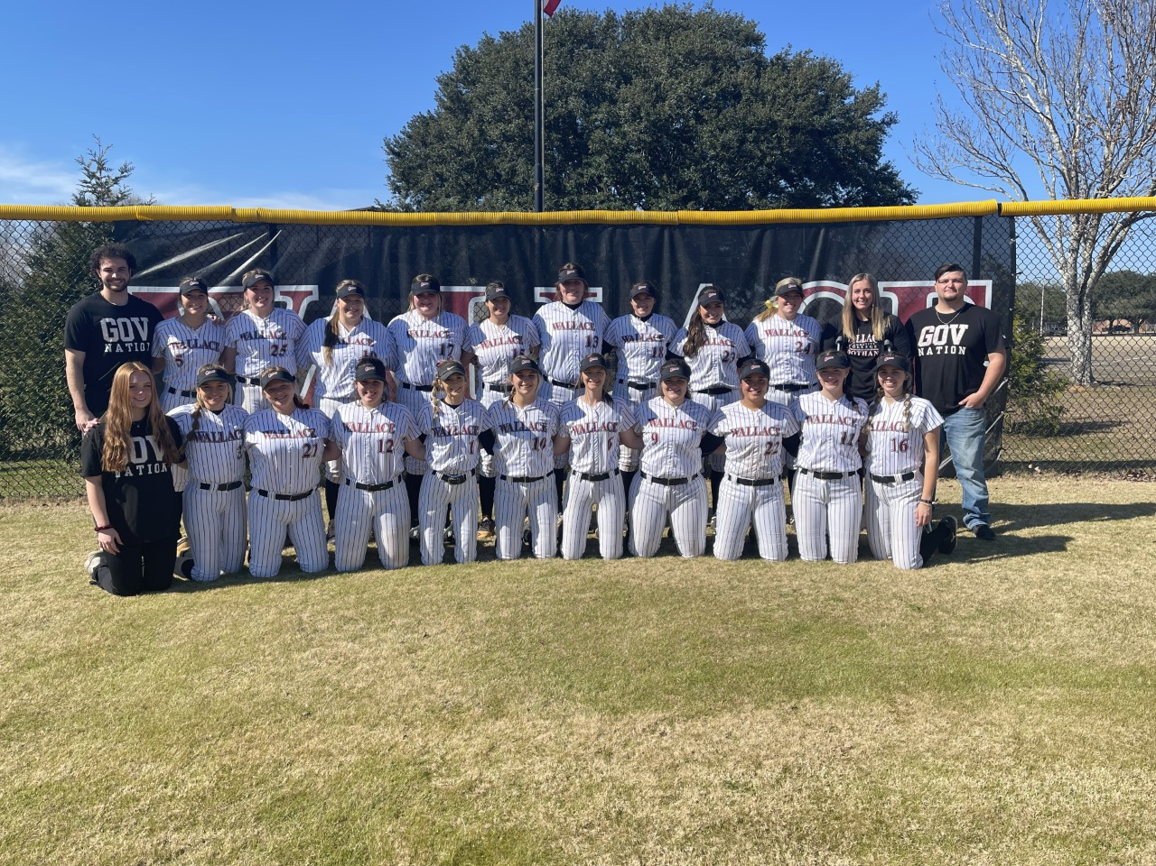

Wallace Community College

PROSPECT CAMP

For 9th – 12th Graders and any unsigned 2023 softball players.

Scheduled for October 1st

9:00 a.m. - 12:00 p.m.

Wallace Dothan Softball Field:

1141 Wallace Dr. Dothan, AL 36303

There will be a $50.00 fee on the day of the camp. Please make checks payable to David Russo.

If possible RSVP to [srevels@wallace.edu](mailto:srevels@wallace.edu)

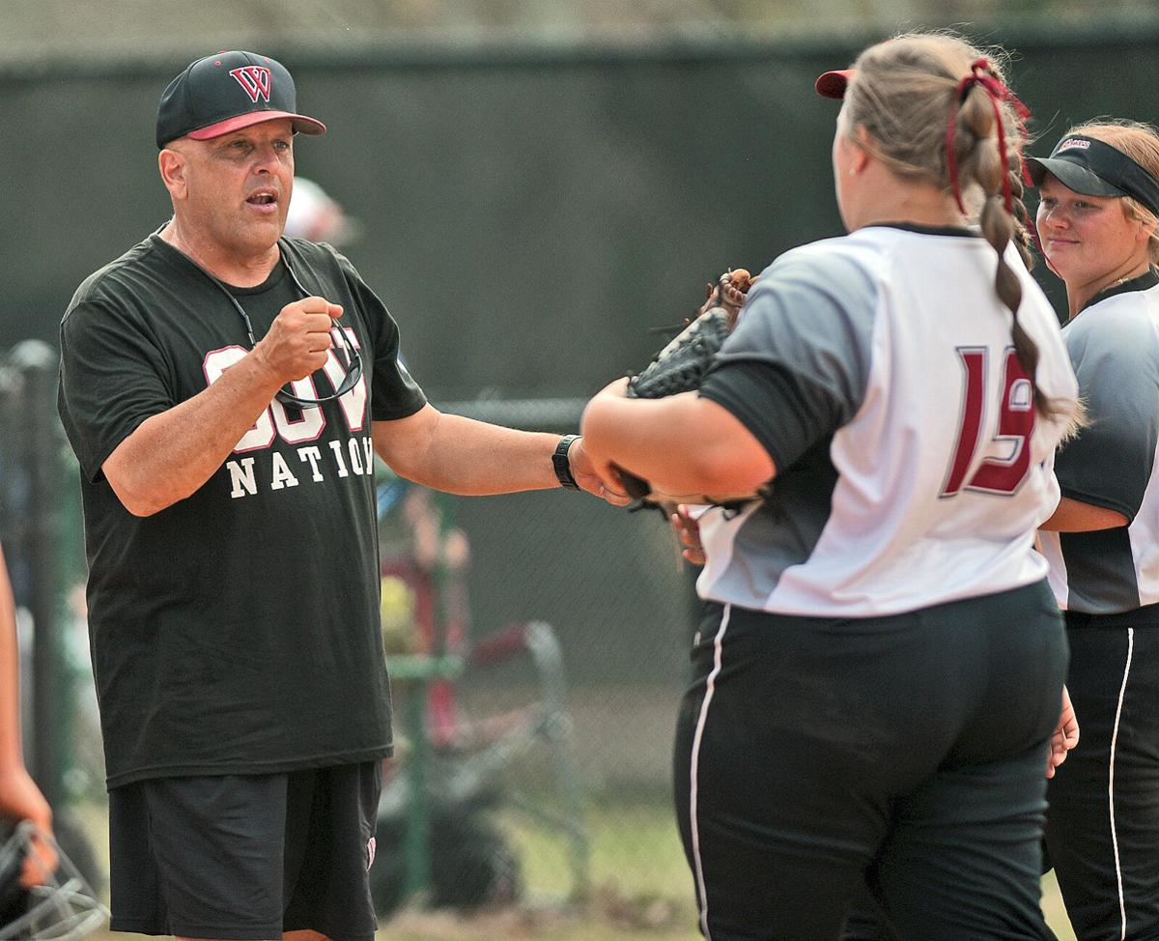

Our Program has many scholarships still available and is currently recruiting for the 2023, 2024, and 2025 graduating classes. If you are in the classes listed above and are interested in our program we look forward to seeing you Saturday, October 1st.

On the day of camp the girls will need their: tennis shoes, cleats, glove, helmet, bat, and catching gear.

|  |
| --- |
|  |
|  |
|  |